|  |  |  |  |  |  |  |  |  |
| --- | --- | --- | --- | --- | --- | --- | --- | --- |
| Forecast Values | |  |  |  | Compiler Engine Information | | |  |
|  |  |  |  |  |  |  |  |  |
| Stand ID: | | 1530588 | | | GYPSY Model: | | 2009-May-21 | |
| Stand Type: | | Natural |  |  | Application: | | 20100713p | |
| Stand Age: | | 38 | years |  | COM DLL: | | 20100329b35 | |
| Spatial: | | NO |  |  |  |  |  |  |
| BA adjusted: | | YES |  |  |  |  |  |  |
|  |  |  |  |  |  |  |  |  |
| Input Data | |  |  |  |  |  |  |  |
|  |  |  |  |  |  |  |  |  |
| Species | | totage | topht | den | ps | ba | utilization | |
| AW |  |  |  |  |  |  | 13/7/30 | |
| SB |  |  |  |  |  |  | 15/10/30 | |
| SW |  | 38.0 | 3.83 | 99 |  | 1.84 | 13/7/30 | |
| PL |  | 30.0 | 3.83 | 397 |  | 7.37 | 13/7/30 | |
|  |  |  |  |  |  |  |  |  |
| Calculated Attributes | | |  |  |  |  |  |  |
|  |  |  |  |  |  |  |  |  |
| Species | | bhage | y2bh | si_bh | si_t | n0 | sdf | psi |
| AW |  |  |  |  |  |  |  |  |
| SB |  |  |  |  |  |  |  |  |
| SW |  | 20.4 | 17.6 | 7.5 | 5.4 | 99 | 99 |  |
| PL |  | 16.2 | 13.8 | 8.4 | 6.7 | 398 | 394 |  |

Tesera Gypsy

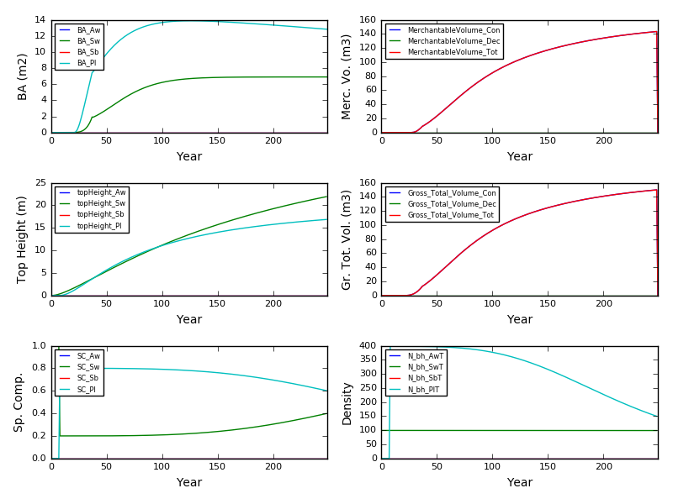

Excel Gypsy

